Module 8: Assignment Final Project

Spurthy Mutturaj

Instructor: Dinesh Sthapit

Dec 2,2022

GitHub:

Landing Page

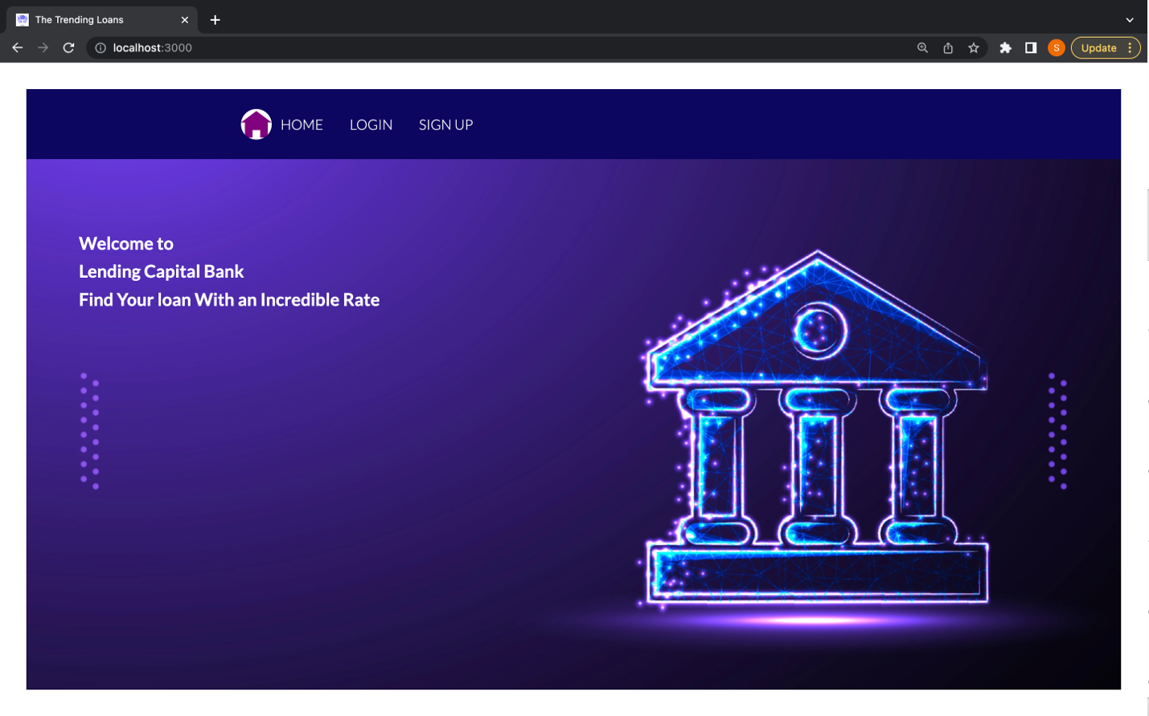Sign Up page:

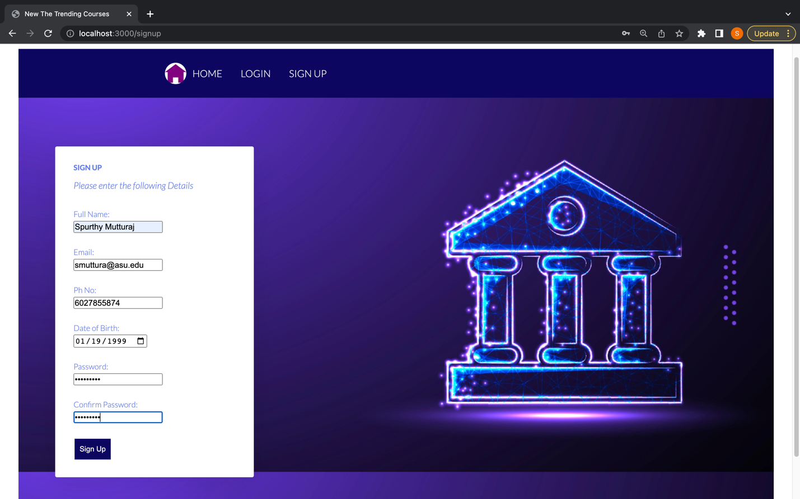

Login Current User:

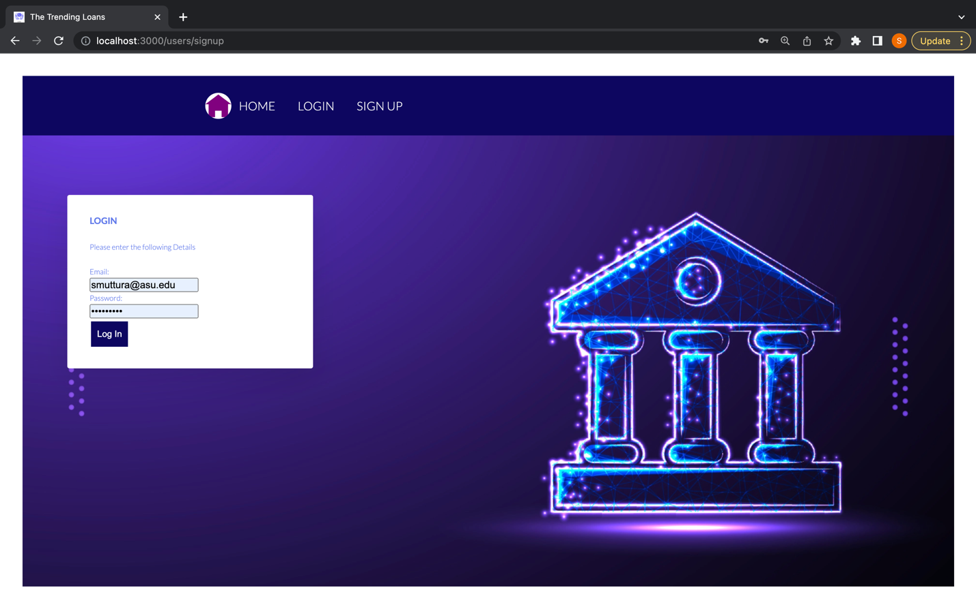

After Logging In:

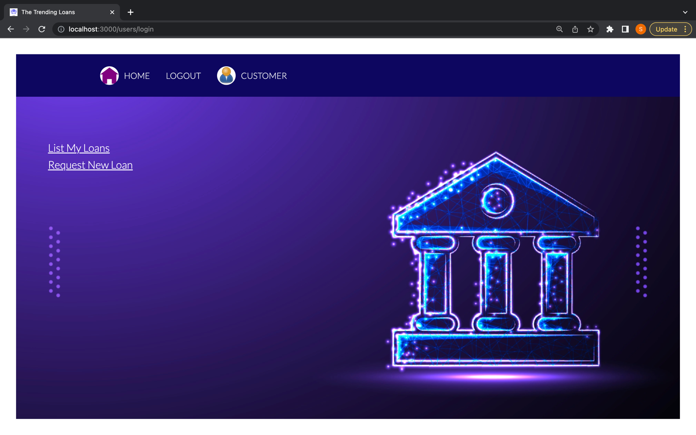

Authentication Cookies with a jwt has been set:

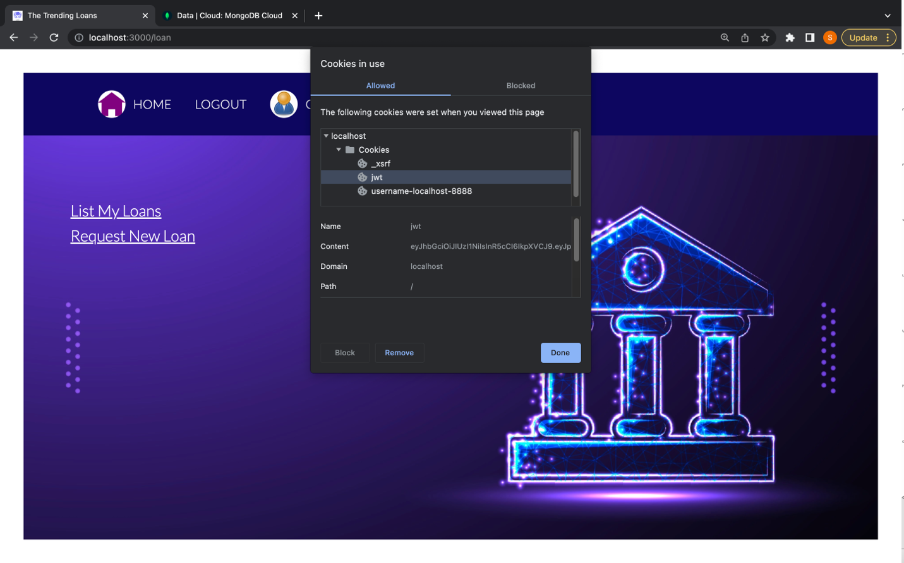

In List My Loans Link, there are no Loans for the new user:

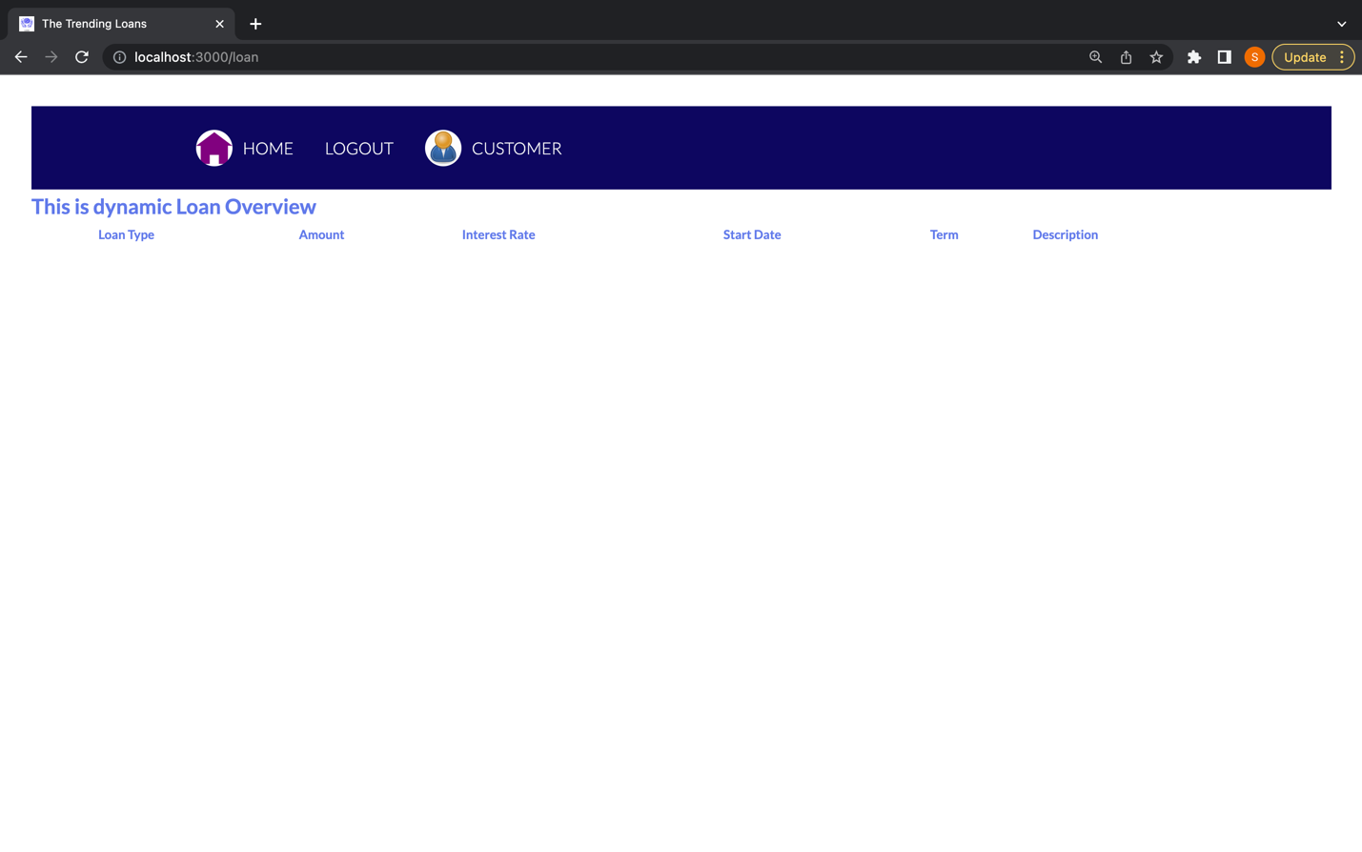

Create New Loans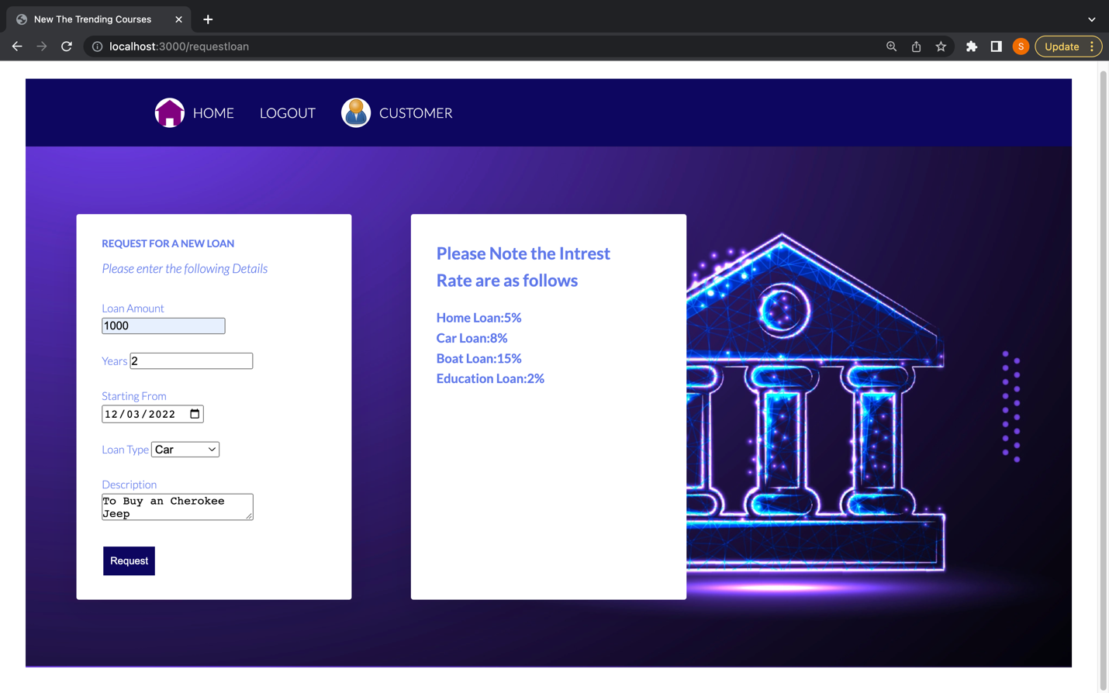

List Loan Details particular to a User

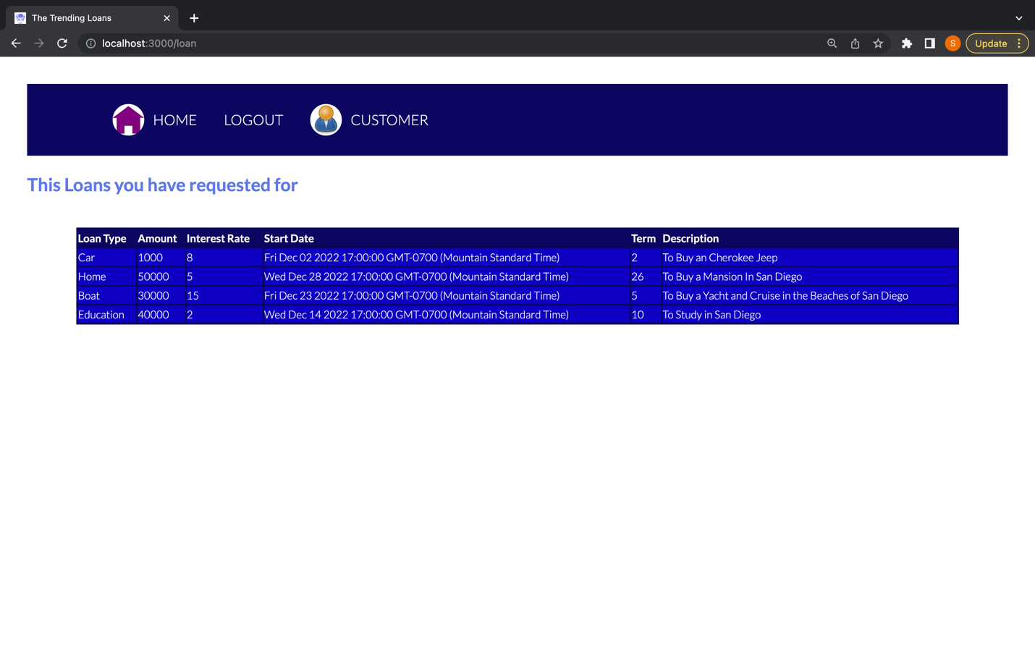

Verification:

There are currently 2 users in the Database:

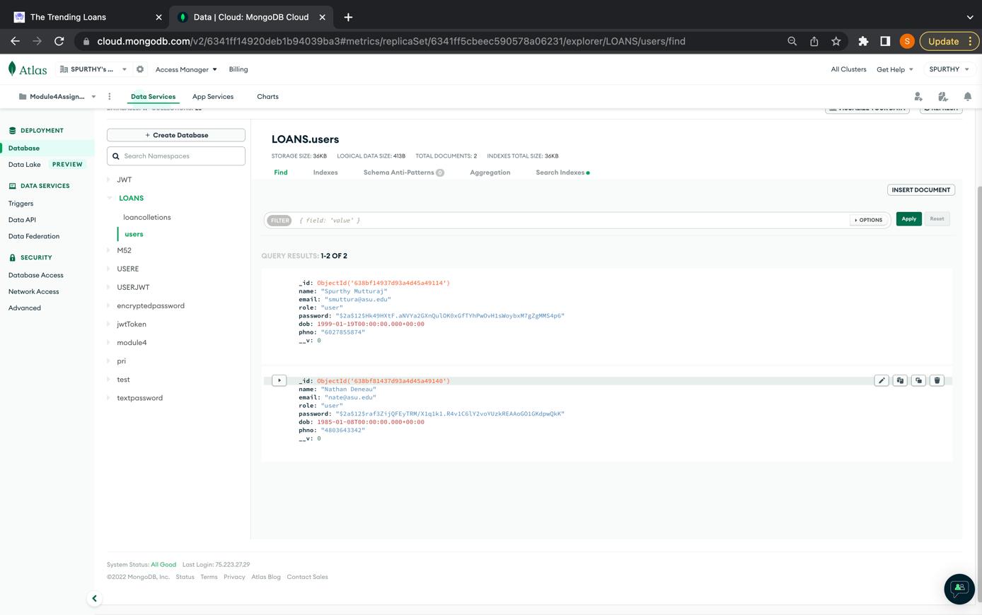

The Database collection contains 6 loans, but only 4 loans belong to the particular user with userID: 638bf14937d93a4d45a49114

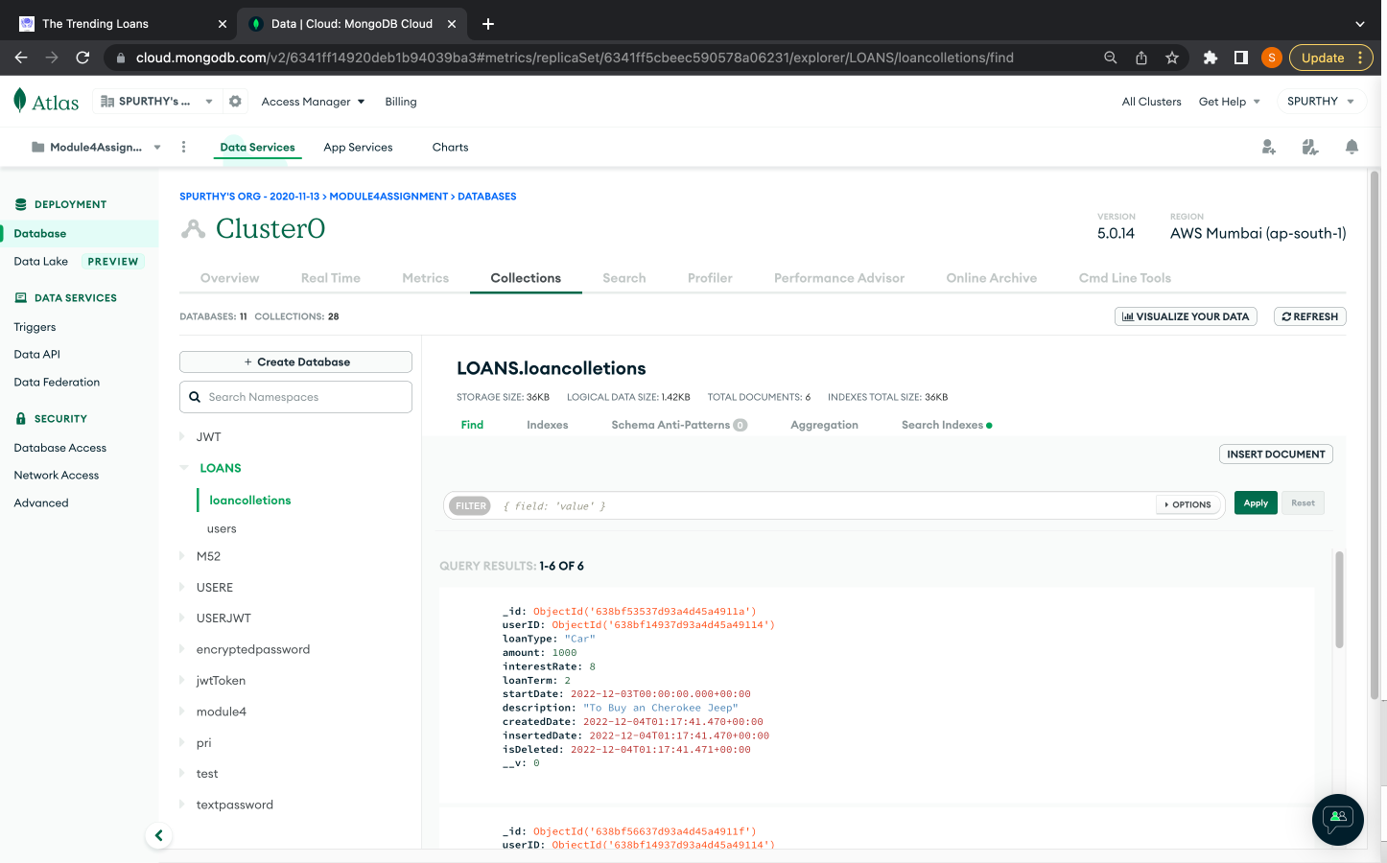

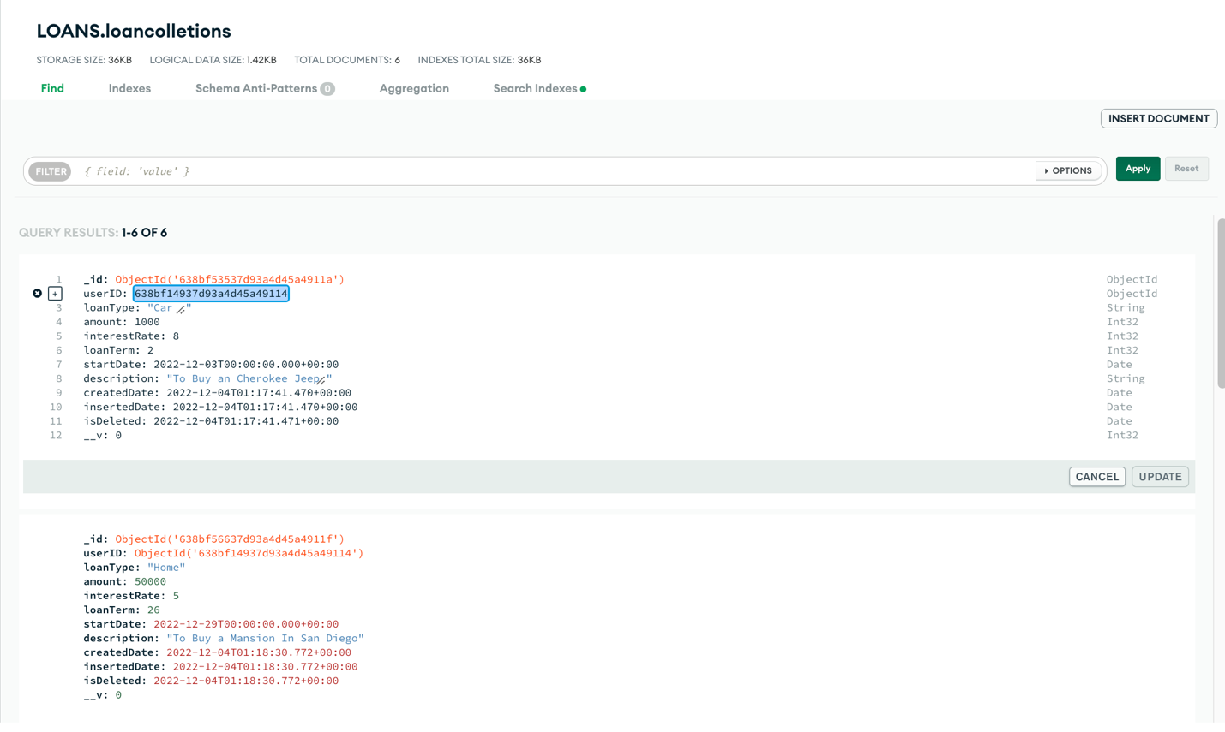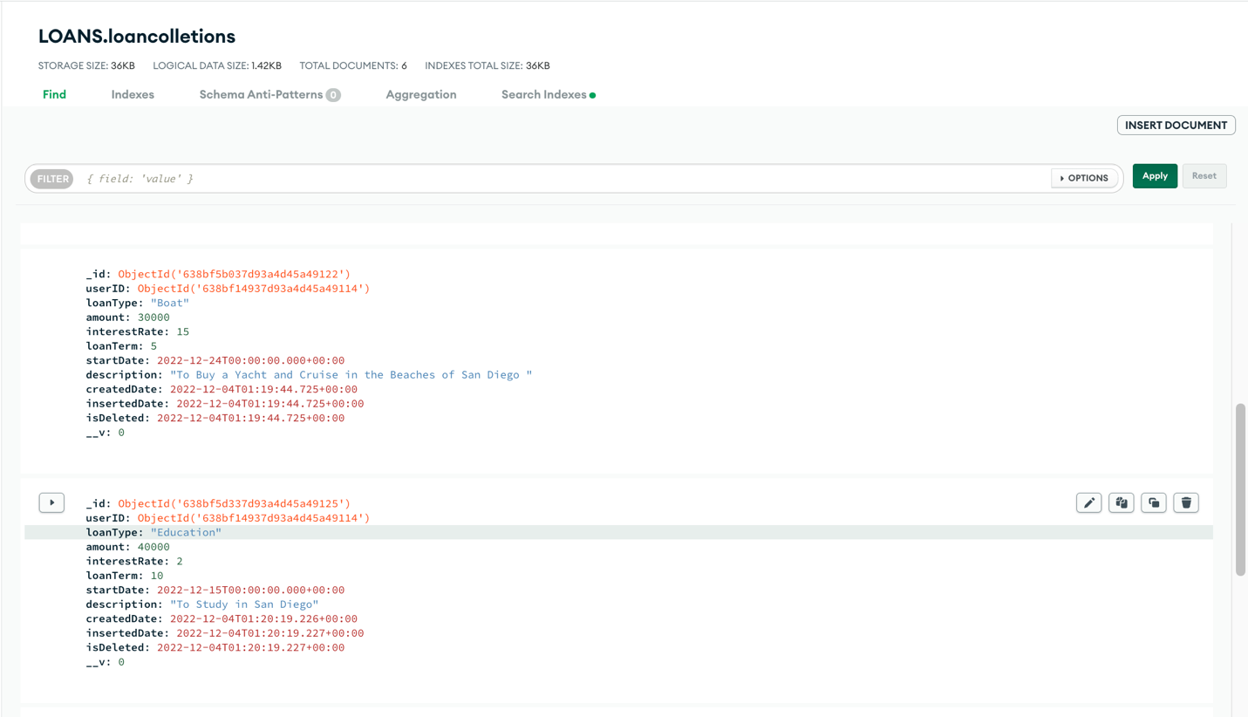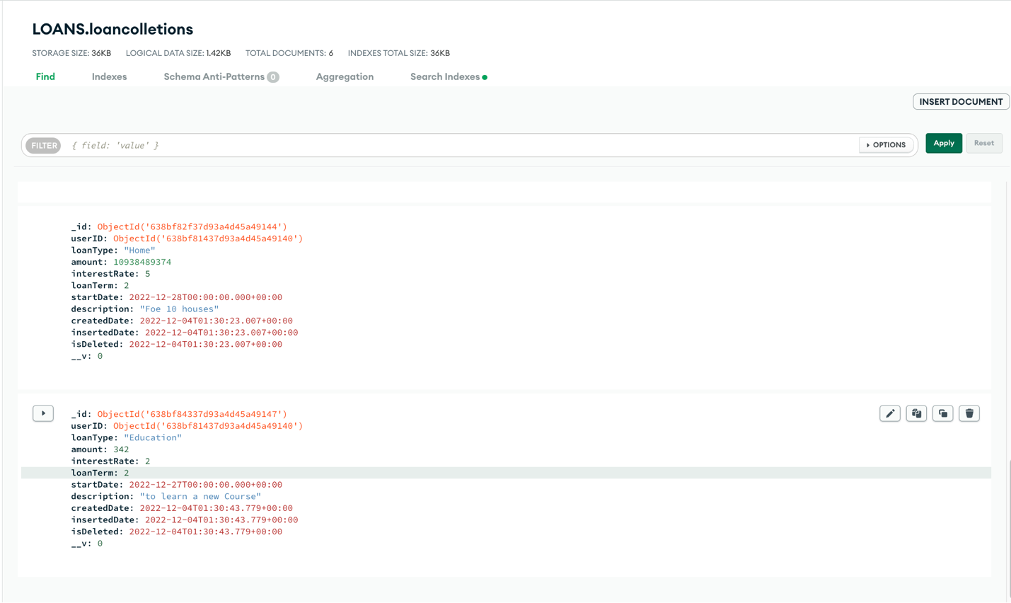

**B. MiddleWare**

Authentication(creating a token)

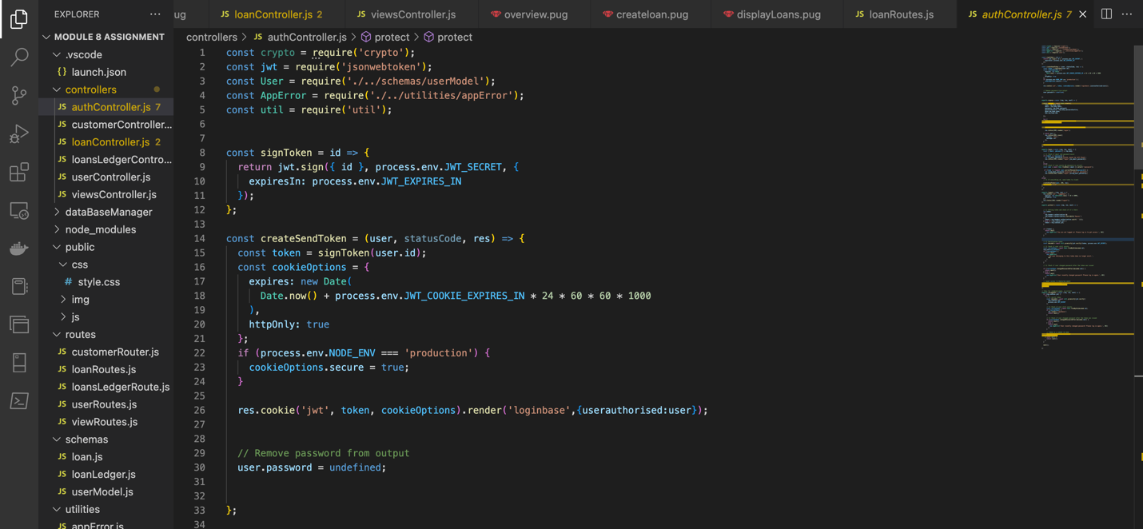

Authorisation(using jwt.verify)

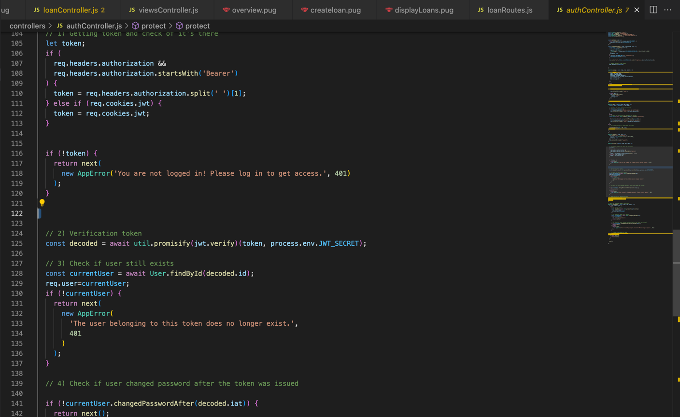Protected Routes

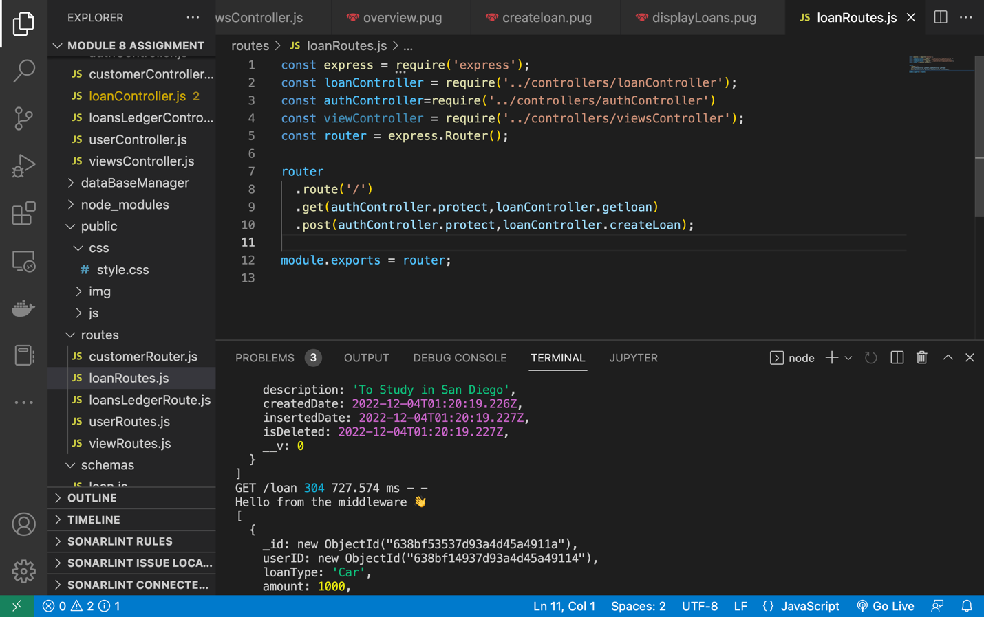

**Backend:**

MongoDB Database LOANS

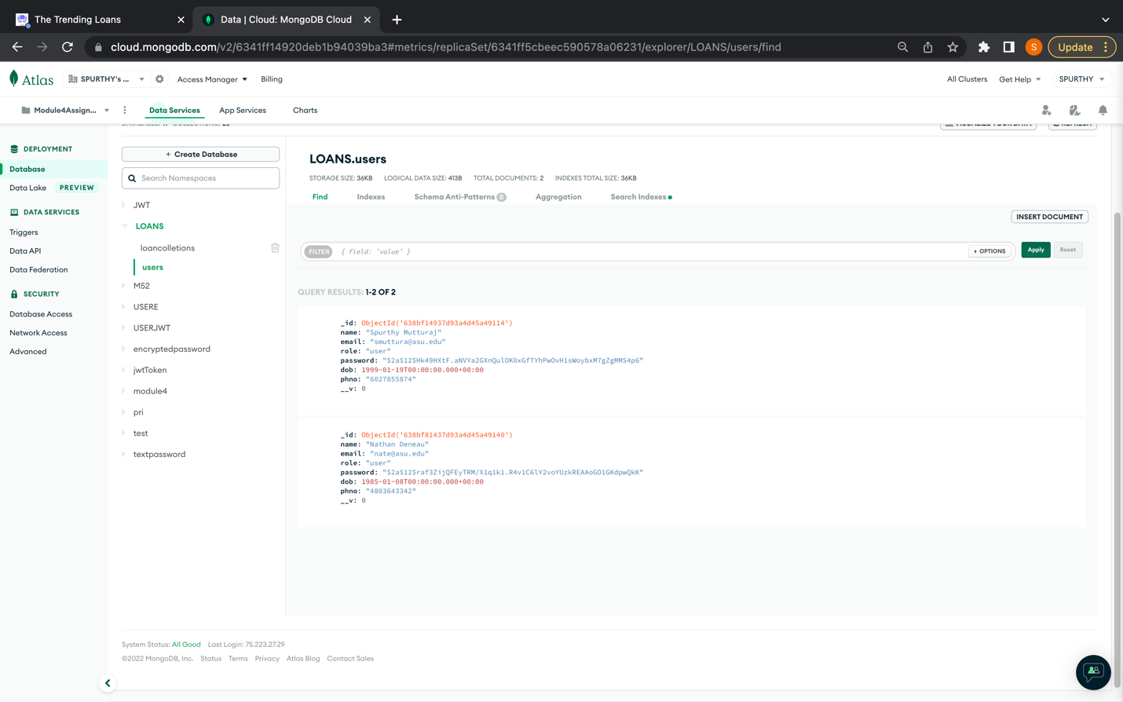

Flow Diagram for Create Loan :

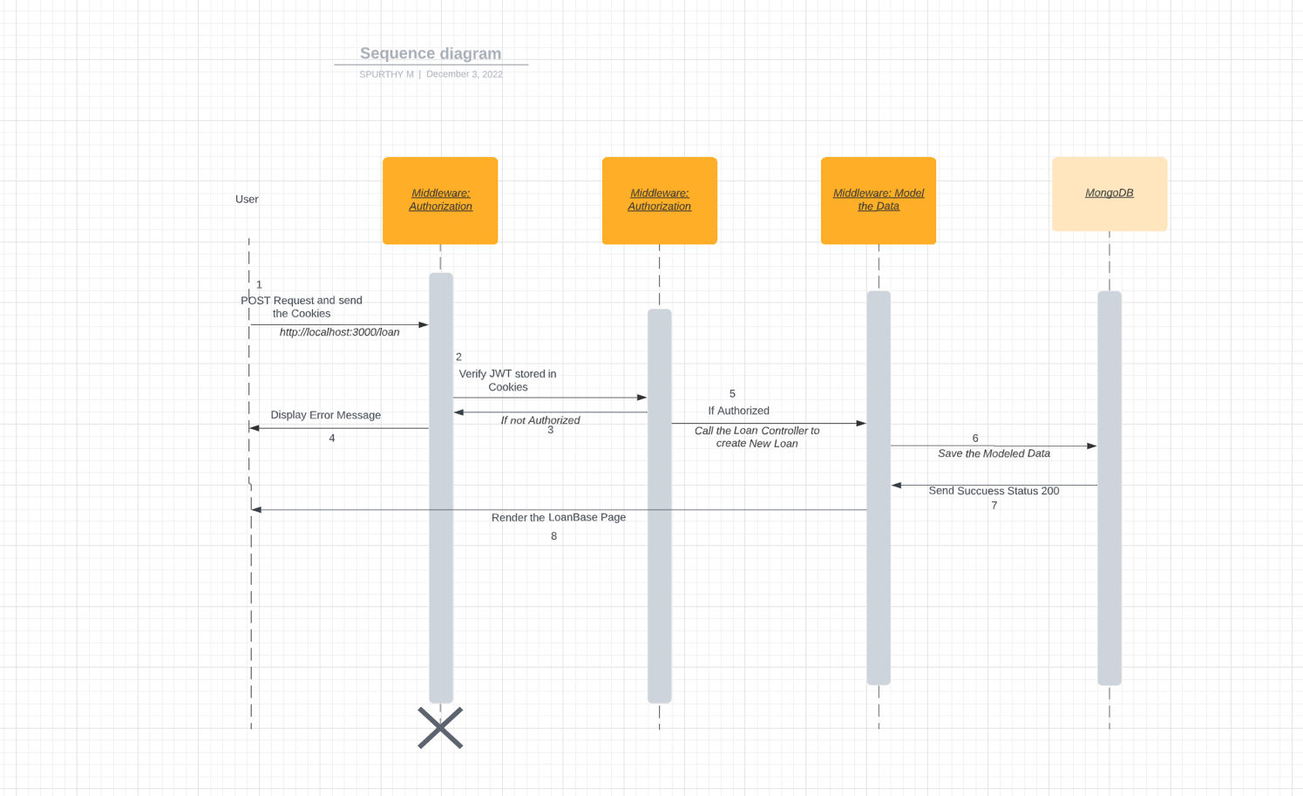

Flow Diagram for List All Loans of a User

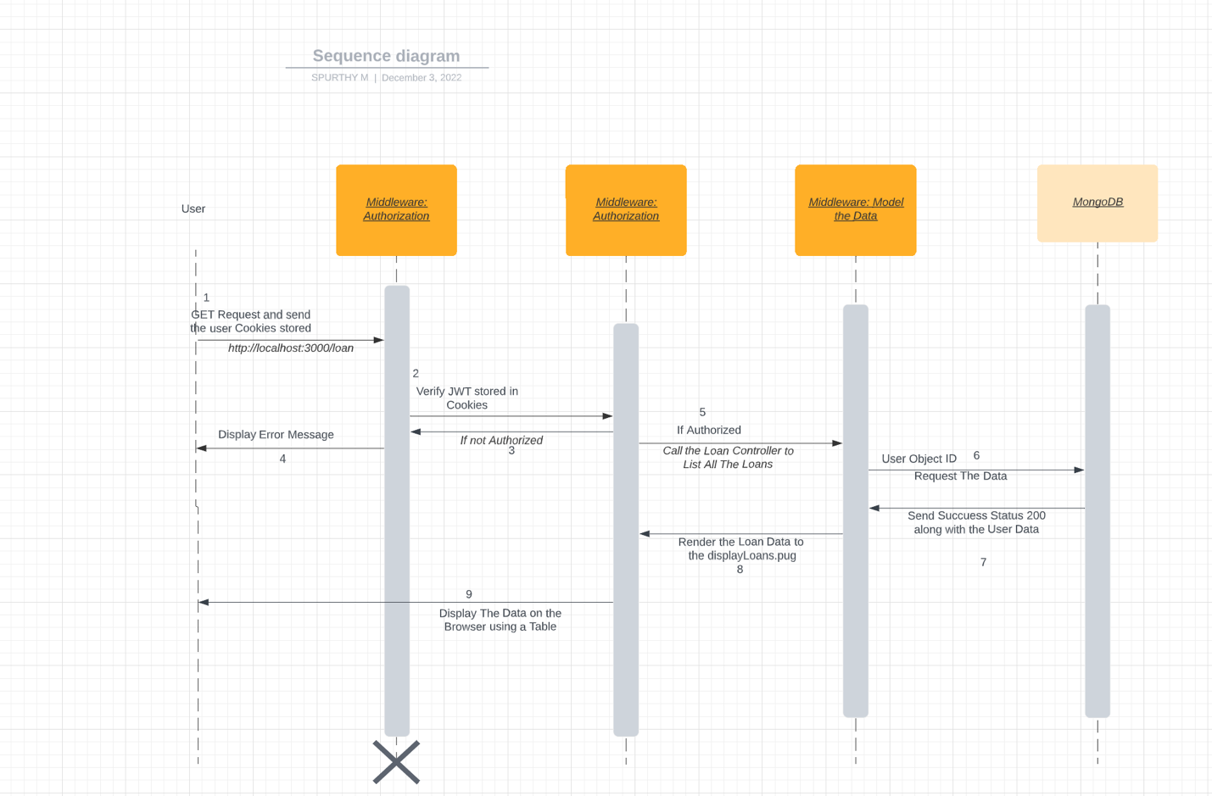

Progress From Module1 through Module 8:

The Course began with installing the Visual Studio Code and a simple web application

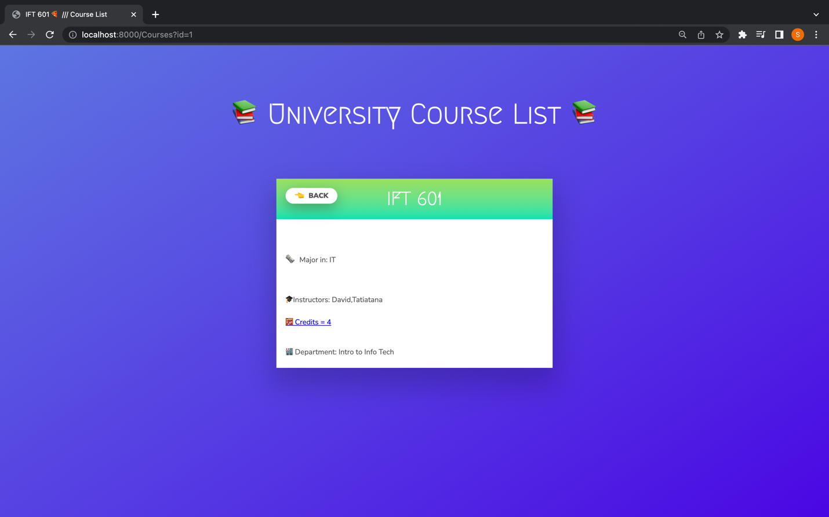

Through Module 2 we learnt about ES6 and arrays and Objects in JavaScript

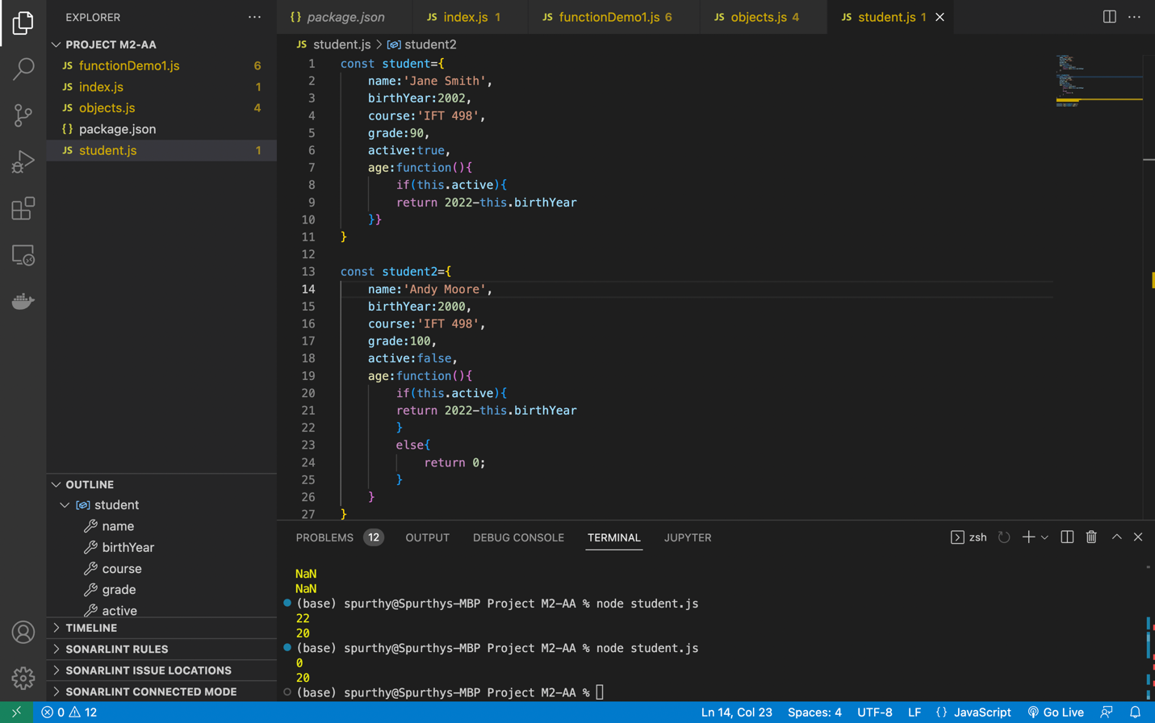In Module3, we explored swapi.dev api and data formats like XML and JSON

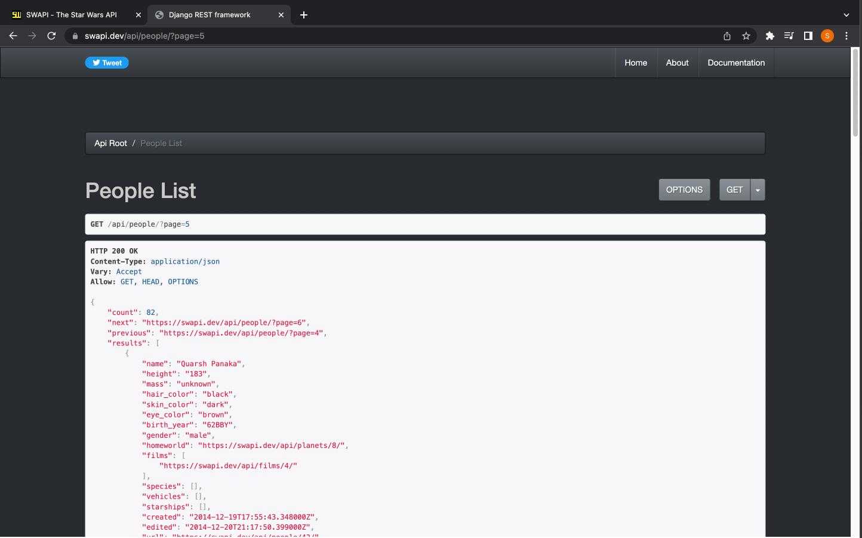

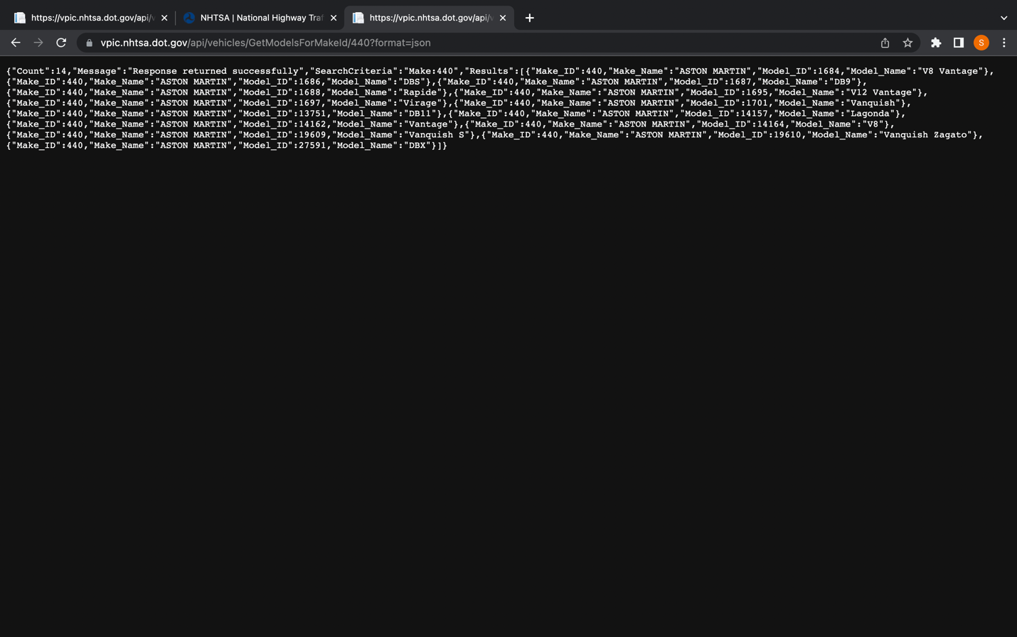

In Module 4, We learnt to connect to the MongoDb and access .

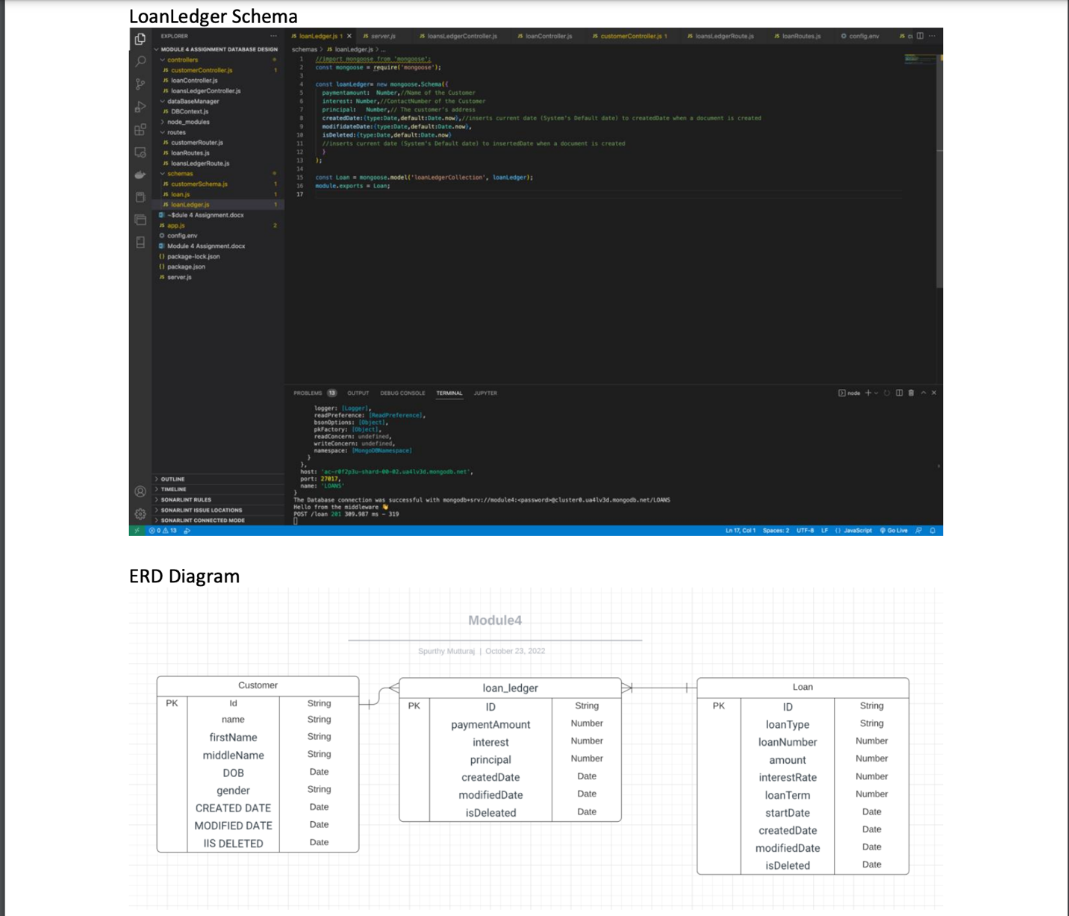

Mongoose Model to store Data: 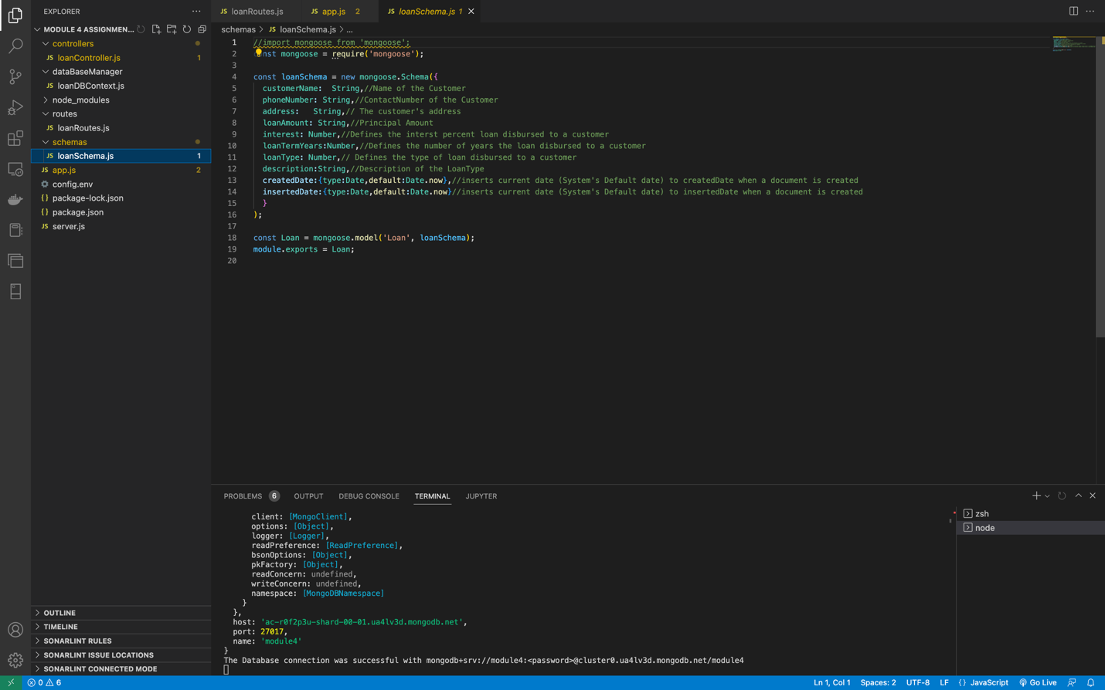

MongoDB:

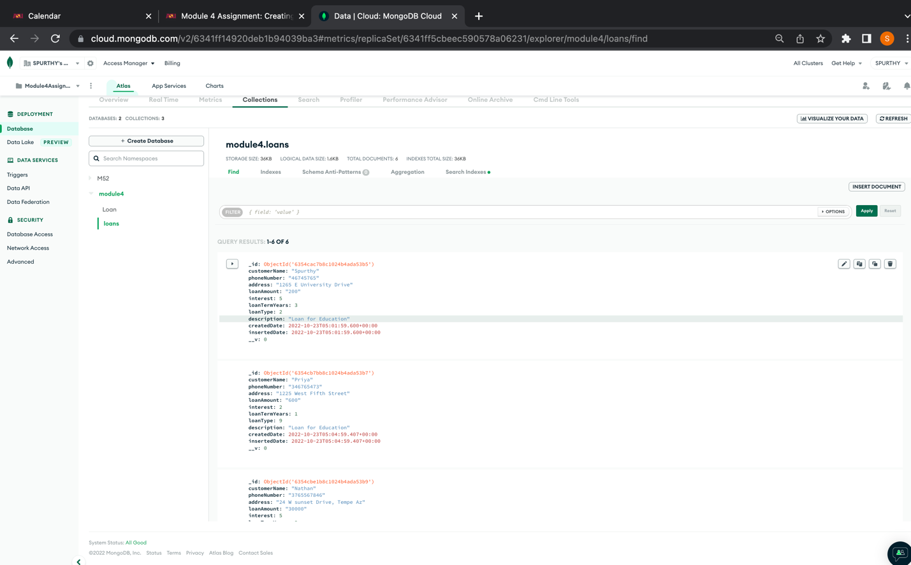

In Module 5 we learnt to store Data and sensitive information in 3 ways: as plain text, Encrypt it and also authenticate a User using JASON Web Token

5 users in DB “textpassword”

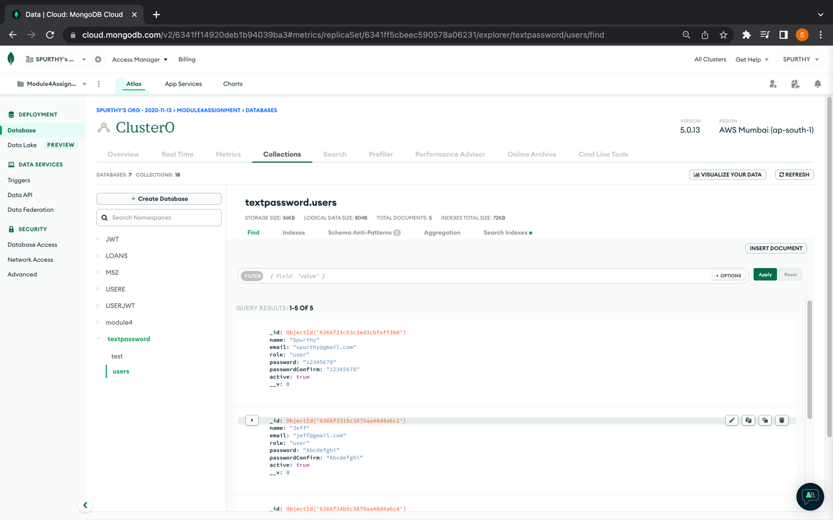

Database –“encryptedpassword” Screenshot

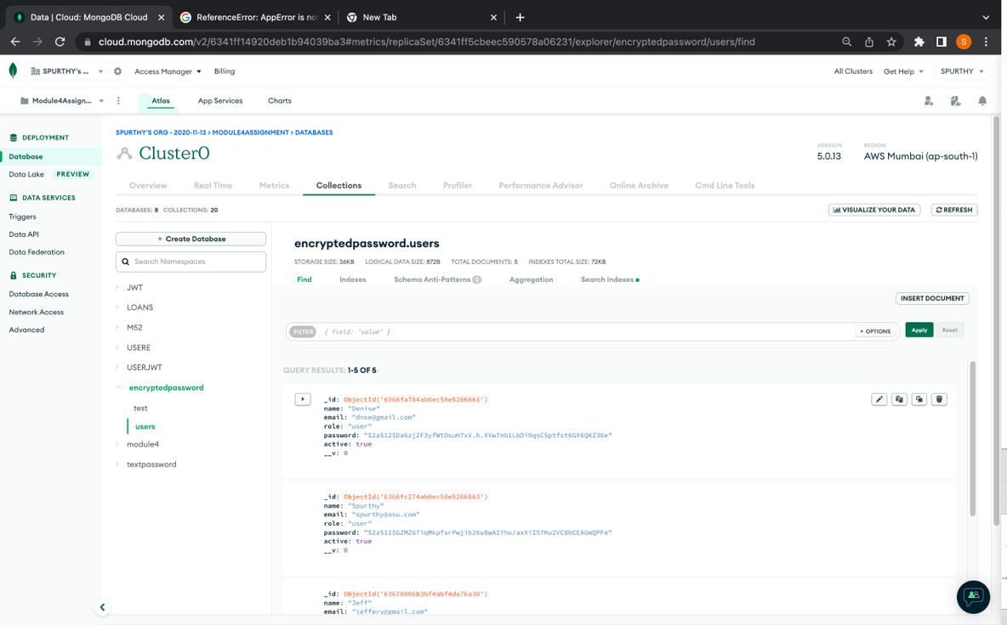

Verifying the JWT created is functional by adding a task :

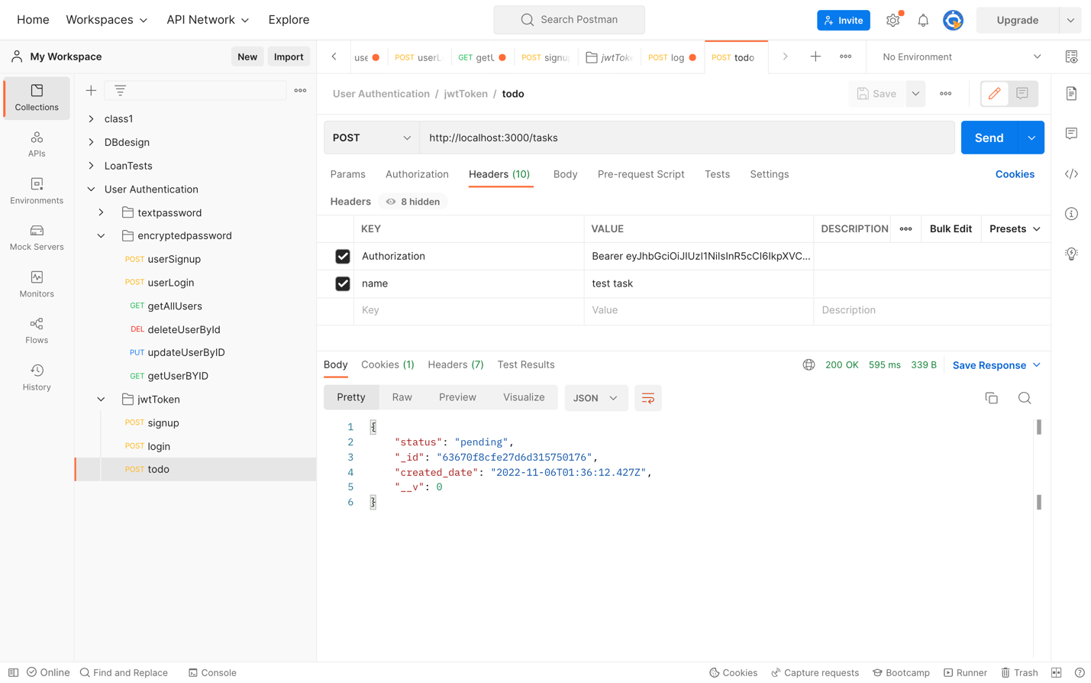

In Module 7: Pages were rendered onto the UI using PUG while retrieving Data from MongoDb:

All Loans Listed: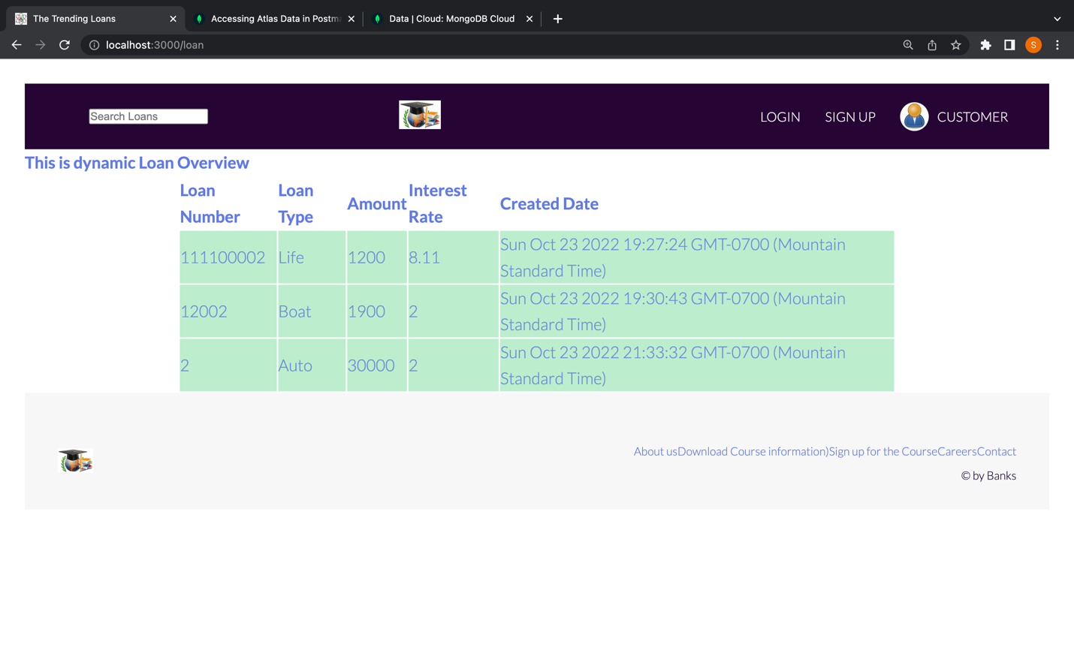

In Module 8- Final Project, we protected the routes and only authorized users were allowed to see data pertaining to them which is stored in the DB. The Web Application is Fully Functional and screenshots of the project is at the beginning of the document.

In the Final Project, I was faced with issues related to :

* authorizing a user,
* storing and retrieving Data Related to the User.
* Display a few set of UI elements only if the User is logged In;
* Rendering the views etc.

I was not aware that protecting routes function was implemented in such a way that they retrieve the cookies, create a token, and verify it. I had a hard time verifying a user and authorizing/ allowing them to see only their data. After the issue was resolved, I faced issues with having connection between data collections stored in MongoDb. I was not able to insert the User ID into the Loan Table (to identify a particular loan entry belongs to the user requesting for it). I figured that the token will also contain the User ID and it should be used to store the Loan data in Loan collections for a particular User.

Major Risk was related to not clearing the cookies and being able to access the loan data even after logging out. This was resolved by suitably clearing out the cookies.

Overall, I am aware of protecting the routes, Authenticate and Authorize a User to the Server and retrieve relevant Data from the Database.